|  |
| --- |
|  |
| De Allocate iLPN |
|  |
| |  |  | | --- | --- | | Project Code | 100488466 | | Project Name | Carter’s Managed Services | |
| |  |  |  | | --- | --- | --- | | Prepared/Modified by | Role | Date of Preparation | | Abhilaikh Nigam | Team Member | 04/04/2018 | | Reviewed by | Role | Date of Review | | Nabee Shaik | Team lead | 04/06/2018 | | Approved by | Role | Date of Approval | | Sabita Prasad | Project Lead | 04/09/2018 | | Circulation List | WMS Team |  | | Version Number | 1.0 |  | |
|  |

|  |
| --- |
|  |

**Issue Description:** When user trying to de allocate iLPN getting an error message “Database Error {0} In {1} ::{2} {3}”.

***Analysis and resolution for De allocate iLPN issue.***

**Severity:** Medium

**Description:** User will get an error message “Database Error” while trying to de allocate the iLPN, sample copy of the email is attached below.



**Scenario 1:**

**Step 1:** Check the stat code in task dtl and task hdr table using the below query (they will be in different status).

select td.task_id, th.stat_code "Hdr Status", td.stat_code "Dtl Status", td.QTY_ALLOC, td.QTY_PULLD from task_hdr th, task_dtl td where th.task_id = td.task_id and td.task_id = '57396886';

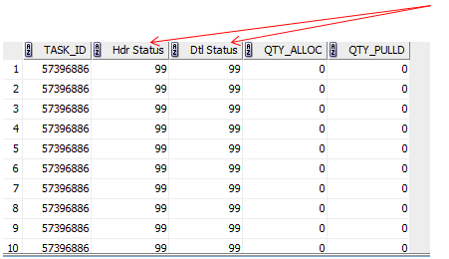

* From the above result we have Hdr status (Task_hdr status) and Dtl status (Task_dtl status). Stat code of these two in different status (we have corrected in above scenario so, there was no difference).

**Step 2:** Update the stat code to 99(cancelled) for the task associated to iLPN in task_dtl, task_hdr and make sure Qty_Alloc and Qty_Pulld should be update to zero in task dtl table before updating the task status to 99 in task dtl using the below queries.

* select task_id, QTY_ALLOC, QTY_PULLD, stat_code from task_dtl where stat_code < 90 and task_id = any ('57396886');
* We are checking the Qty_Alloc, Qty_Pulld, stat_code in the task_dtl which is less the 90 status and then updating the Qty_Alloc, Qty_Pulld to zero and stat code to 99. (Always need to zero out Qty_Pulld and Qty_Alloc when doing a manual cancel on a task detail)
* Update task_dtl set QTY_ALLOC = 0, QTY_PULLD = 0, stat_code = 99 where stat_code < 90 and task_id = any ('57396886');
* Now task dtl has been updated to 99(cancelled status) along with Qty_Alloc and Qty_Pulld as zero. Then need to update the task hdr using the below Step 3.

**Step 3:** Update the task_hdr status to 99 using the below query (here we don’t need to check for Qty_Alloc and Qty_Pulld).

* select task_id, stat_code from task_hdr where task_id = any ('57396886');
* update task_hdr set stat_code = 99 where task_id = any ('57396886');

**Step 4: Go to UI and search for iLPN as shown in the below screen then enter the iLPN.**

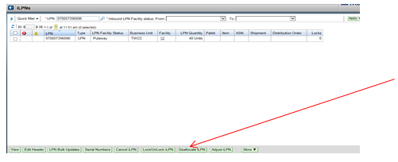

* Check the iLPN and click on De allocate iLPN as shown in the above image then it will move to 30 status (put away status same as case deallocation issue we usually do for DC33 and DC44).

**Scenario 2:**

**Issue Description:** User receives an error on oLPN saying below.

**Error:** “LPN is allocated for Order and cannot be deallocated”

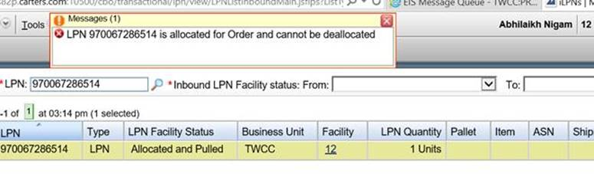

**Resolution:**

**Step 1:** check the open allocations through below query:

select * from DM.ALLOC_INVN_DTL where cntr_nbr in (970067286514) and stat_code < '90';

**Step 2:**

* Login to DC12 UI
* Go to System Codes in UI.
* Give ‘Code Type’ as CCF and click on apply button.

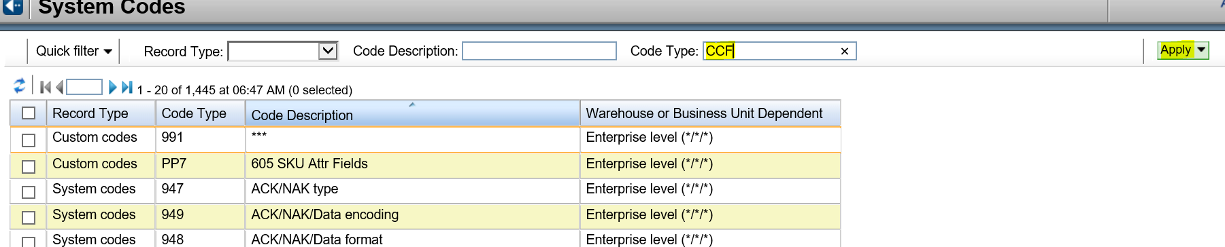

* Checkbox the Custom codes and click on Code Ids.

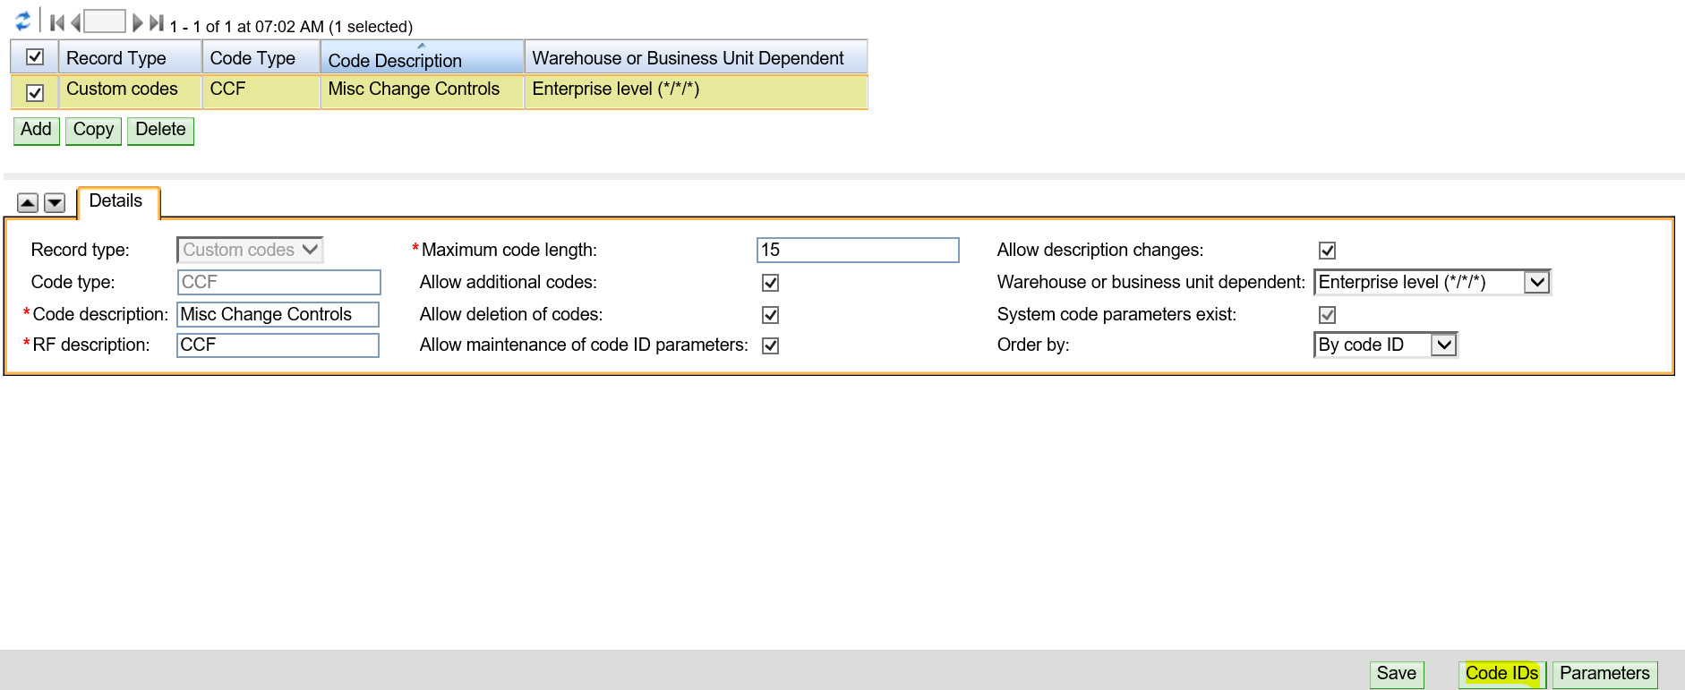

* Checkbox the Code Id De-Allocate, enter the Tote number and checkbox the activate button under parameters tab.

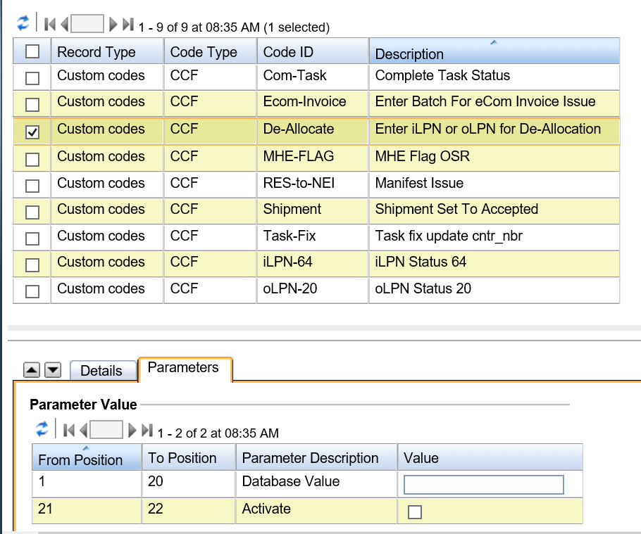

* Click on save button and wait for 5 mins to update the status of open allocations.

**Step 3:** Go to UI and search for iLPN as shown in the below screen then enter the iLPN.



* Check the iLPN and click on De allocate iLPN as shown in the above image then it will move to 30 status.